**Coursework Report**

G53GRA

Bohao Zhi

4285624

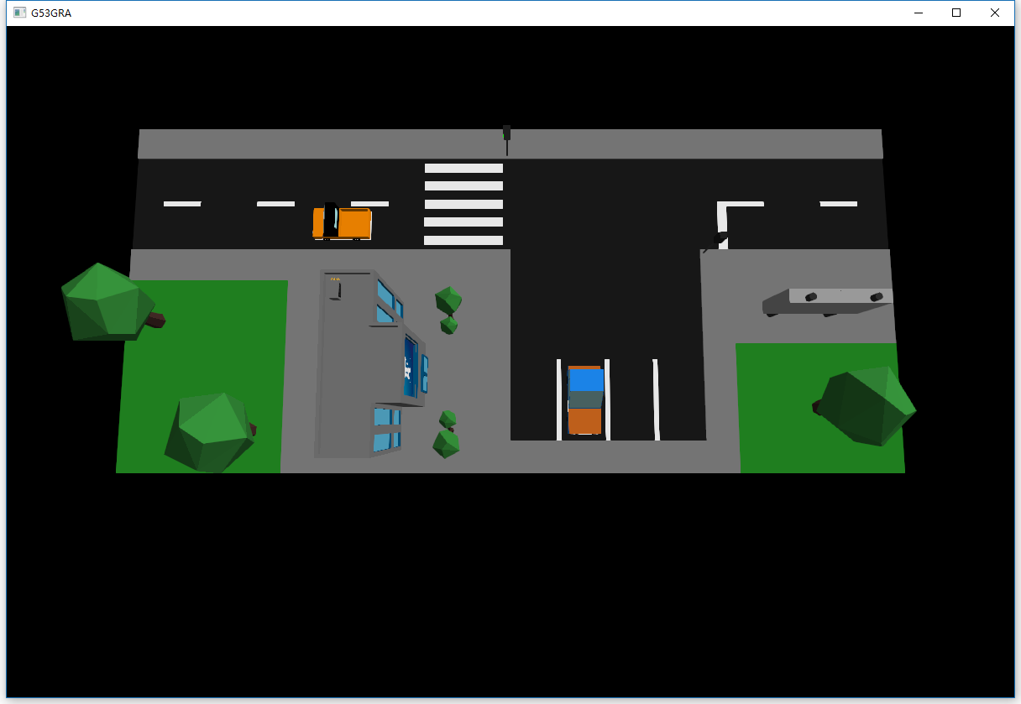

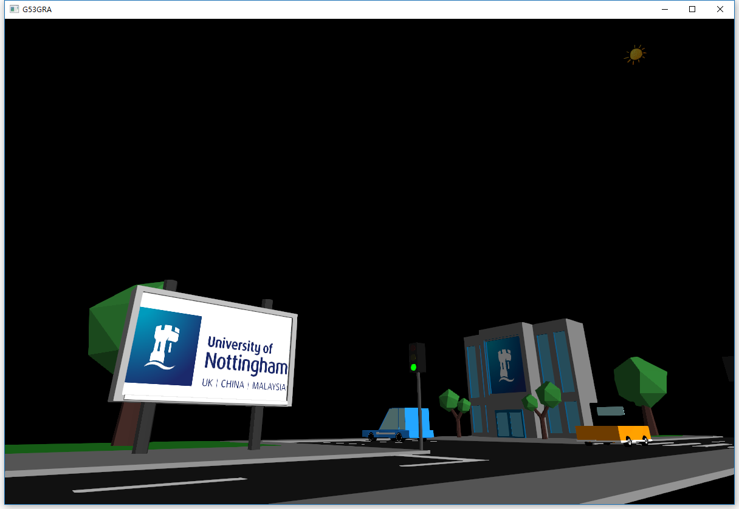

1. 3D Modelling / Hierarchical modelling

There are several basic objects in my scene, billboard, building, two cars, road (including zebra crossing, parking area, grass land and sidewalk), two kinds of trees and two traffic lights. Road and traffic light are created on OpenGL using basic 3D objects (cubes and spheres). Others are created using Blender.

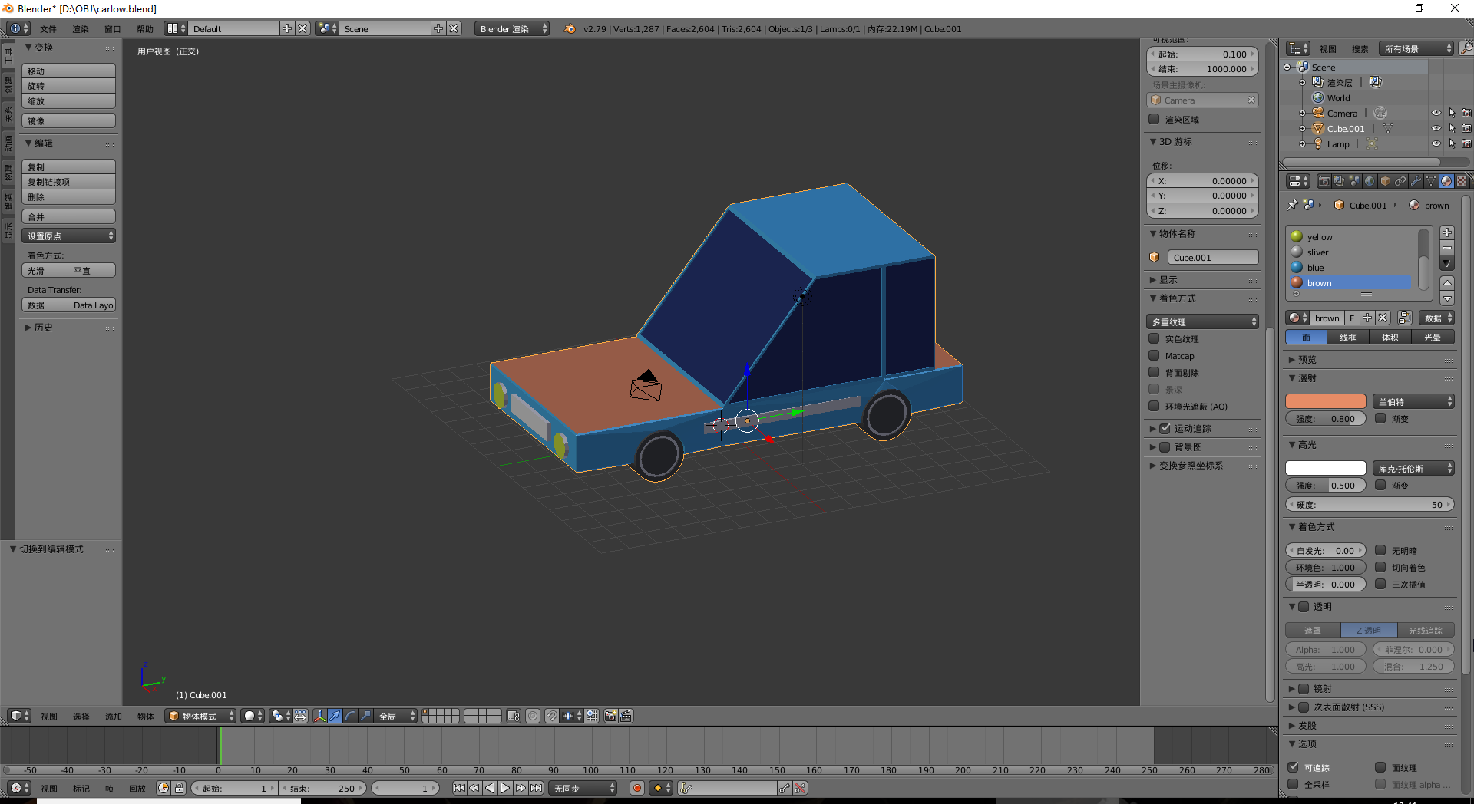

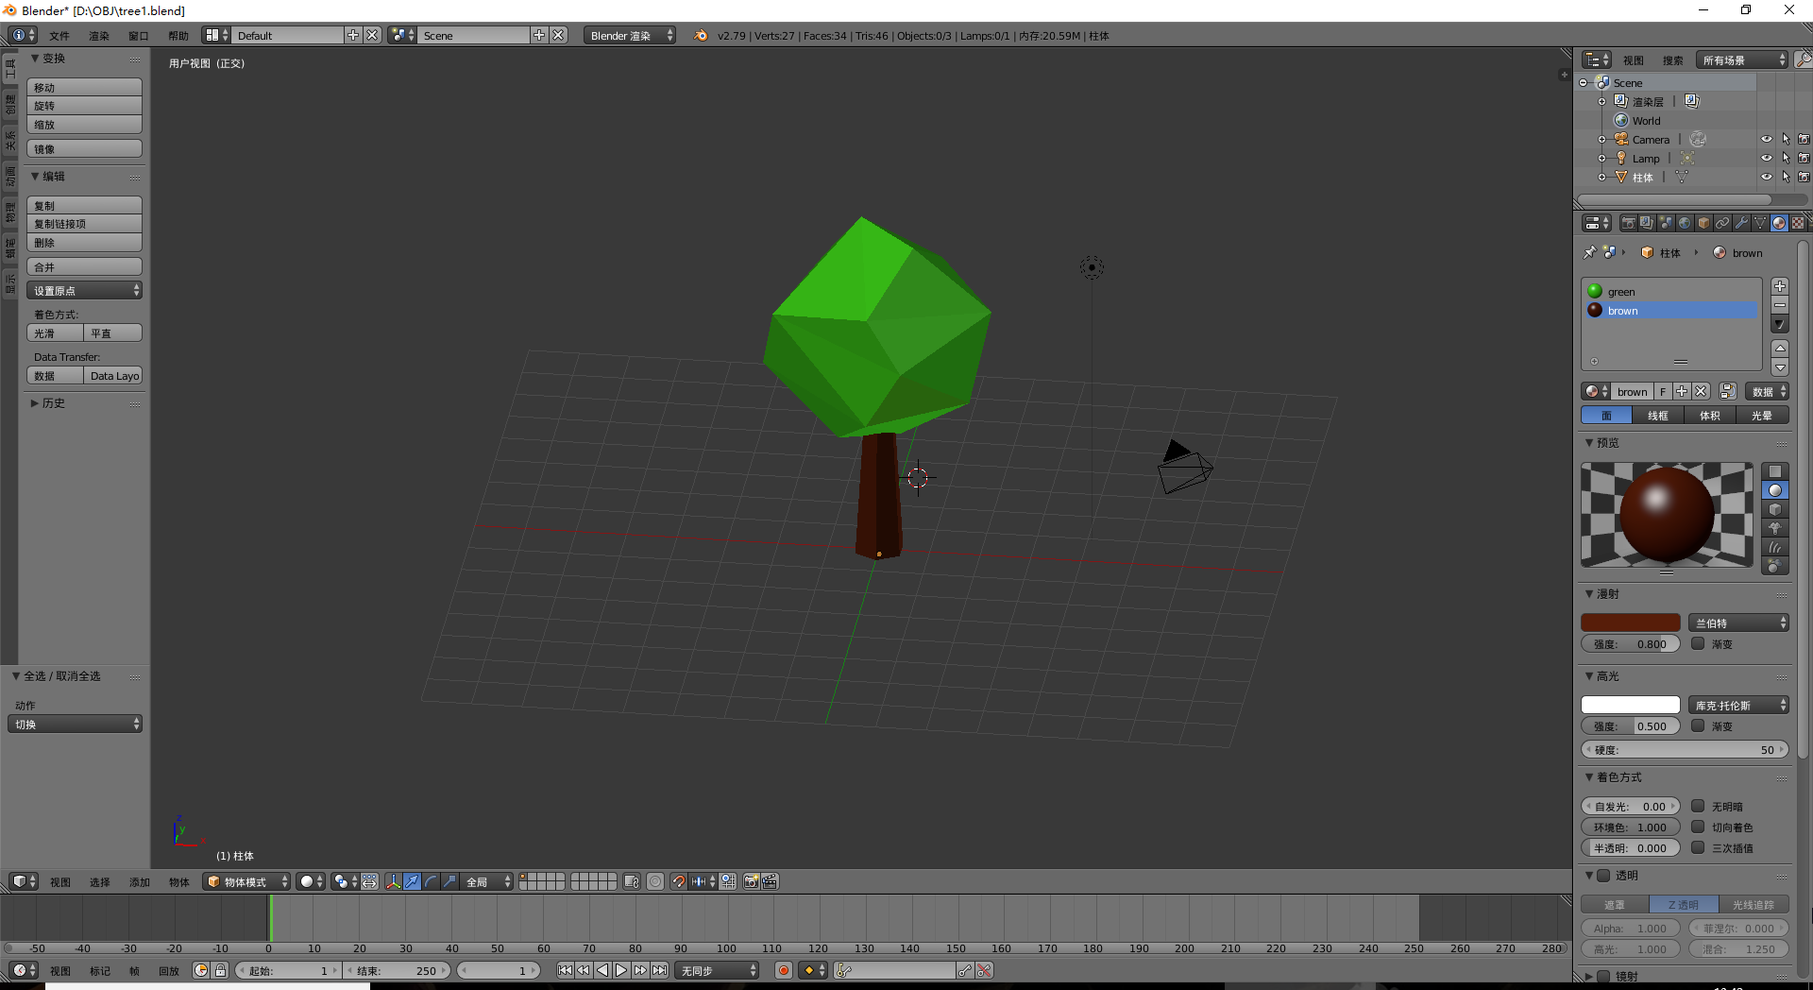

After created in Blender, I use ObjLoader, which is a C++ class inherits DisplayableObjects class to read the Object format file and import the model to OpenGL. Vectors, normal vectors and index of vectors and normal vectors in each face are saved. Then use GL_TRIANGLES to draw the object in OpenGL.

1. Animation

There are three animation objects in the scene. First, the traffic light can change the lights among red, yellow and green.

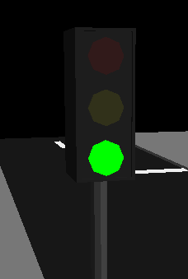 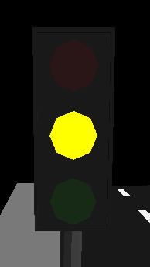 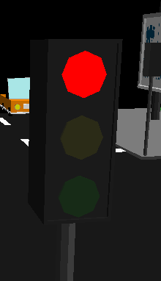

Second, car runs on the road and will stop and start according to the traffic light.

Third, the texture on the billboard will scroll down and up automatically.

1. Light & Texture

GL_LIGHT0 and GL_LIGHT1 are used. GL_LIGHT0 is the environmental light source used to simulate the sunlight. GL_LIGHT1 is directional spot light source used to simulate moonlight. Users can press ‘E’ to switch the light.

There objects use texture. First, the logo on the building is texture. Second, the post on the billboard, which is an animation texture, can scroll down and up automatically. Third, the texture of sun and moon.

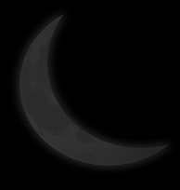

Billboard method is used here. The moon and sun are always facing to the camera. The texture can rotate itself according to the view of camera automatically.

1. View & Projection

I add four additional buttons. Press “Q”, the camera will move down to the ground. Press “J” or “K”, the camera will move up and down respectively. The camera will not below to the ground. Press “E”, the light will switch, and texture will change to Sun or Moon according to the light.

In addition, I add an animation after pressing space bar. The camera will turn to the ground below slowly.

1. Summary & Reflection

All requirements of coursework are meet in the scene. Using basic objects to create a complicated model is a challenge in OpenCV. Thus, I use Blender to create the models first. Then use ObjLoader to import the models to OpenCV. Another challenge is the texture of Sun and Moon. In order to make them look more real, the billboard method is used. By searching the internet, the website[1] gives me lots of help to realize the method.

To make the scene more real, shadow should be added. And the black background looks a kind of empty, more objects, such as cloud, can be added.

1. Billboarding Tutorial: http://www.lighthouse3d.com/opengl/billboarding/